MSOM Research Challenge Data Paper

2019-07-12

JD.com

**JD.com: Transactional data for the 2020 MSOM Data Driven Research Challenge**

Max Shen (University of California, Berkeley), Christopher S. Tang (University of California, Los Angeles,), Di Wu (JD.COM American Technologies Corporation), Rong Yuan (Stitch Fix), Wei Zhou (JD.COM American Technologies Corporation)   
  
August 20, 2019

*Abstract*

To support the 2020 MSOM Data Driven Research Challenge, JD.com, China’s largest retailer, offers transaction level data to MSOM members for conducting data-driven research. This article describes the transactional data associated with over 2.5 million customers (anonymized) and 31,868 SKUs over the month of March in 2018. We also present potential research questions suggested by JD.com. Researchers are welcome to develop econometric models or data-driven models using this database to address some of the suggested questions or examine their own research questions.

Keywords: E-Commerce, Transactional Data, MSOM Society, Data Driven Research

# 1. Introduction

The growth of e-commerce retailing (or E-tailing) has given rise to many new and challenging problems at both strategic and operational levels. To encourage Operations Management (OM) researchers to conduct data-driven research in E-tailing, we describe the data provided by JD.com that are intended to enable researchers to examine research questions arising from customer purchasing decisions and supply chain operations in the context of E-tailing.

JD.com is China’s largest retailer with a net revenue of US$67.2 billion in 2018 and over 320 million annual active customers. According to the official description provided by JD.com, “*JD.com is committed to providing only high-quality, authentic products, and is known for its fast delivery speed. JD.com sets the standard for online shopping through its commitment to quality, authenticity, and its vast product offering covering everything from fresh food and apparel to electronics and cosmetics. JD.com combines its business model of first party, where it controls the entire supply chain, with a marketplace that intentionally limits the number of sellers, to ensure that it can maintain strict quality oversight. JD.com has a nationwide fulfillment network covers 99% of China’s population, and is able to provide standard same- and next-day delivery as standard for approximately 90% of orders.”*

The data sets provided by JD.com capture a “full customer experience cycle” that begins at the moment when a customer browses through products available on the platform before placing his or her order and ends at the moment when the customer receives the products at his or her designated location. The data sets provide information on 2.5 million customers over 30,000 SKUs in one specific product category during the month of March in 2018.

Based on our discussion with the management of JD.com, we developed the following set of research questions. We encourage researchers to explore the provided data and develop innovative solutions to address the following problems (or other research problems of their own choosing):

1. Which product attributes and/or features have predictive power about **customer’s product choice**? Does **customer’s product choice** differ by channel (e.g., purchasing via mobile phones versus personal computers), by region, and by brand loyalty?
2. Would more products with similar attributes and features improve or hinder sales revenues for JD.com?
3. For a specific target customer segment (e.g., female customers in a tier 1 city), what should merchants and brands do to improve their sales performance?
4. What is the impact of various pricing and promotion strategies on product sales? How should JD.com improve its pricing and promotion strategy? In particular, among all the promotion methods (e.g., direct discounts, bundle discounts, and volume discounts), which one is more effective?
5. Do ordinary customers behave differently from JD.com’s PLUS members?[1] How should JD.com improve its pricing and shipping strategy for its PLUS members?
6. How should JD.com improve its **demand forecast** accuracy for different geographic regions and different customer groups?
7. How should JD.com improve its fulfillment efficiency and customer experience with better **inventory allocation** strategies in a multilevel inventory network?

# 2. Data Description

We now describe the transactional data provided by JD.com. (We shall explain how to download the database and the Python code in Section 4.) To ensure confidentiality, certain key identification information such as user ID and Stock Keeping Unit (SKU) ID are fully anonymized.[2]

In the database, each SKU can be identified either as “*first party owned*” (1P) or “*third-party owned*” (3P), depending on the ownership of the inventory of that SKU.[3] All 1P SKUs are managed by JD.com, including product assortments, inventory replenishments, product pricing, order deliveries, and after-sales customer services. Despite different operations, 1P and 3P SKUs compete on the JD.com platform for sales through different pricing strategies and marketing activities.

In general, 1P SKUs are usually top sellers within the category. By owning these 1P products, JD.com can fully control the entire customer experience to provide guaranteed quality, fast delivery, and good customer services. By contrast, all 3P SKUs are managed by third-party merchants on the JD marketplace. Specifically, to fulfill an order of a 3P SKU, the corresponding merchant can decide freely whether to use the logistics services provided by JD Logistics or other logistics service providers.[4]

The data sets provided by JD.com offer a detailed view on the activities associated with all SKUs within one anonymized consumable category during the month of March in 2018. Owing to confidentiality, the specific category is not disclosed. The data set consists of seven tables that are labeled as(1) *skus*, (2) *users*, (3) *clicks*, (4) *orders*, (5) *delivery*, (6) *inventory*, and (7) *network*. We now describe each of these seven tables.

1. **Table: skus**

The *skus* table (Table 1) describes the characteristics of each of the 31,868 SKUs that belong to a single product category. We now define each field along with a brief description. Each entry in the *skus* table corresponds to a unique SKU (*sku_ID*). In addition, each SKU ID is “seller-specific.” For example, an identical product that is sold by JD as a 1P product and by a third-party seller as a 3P product will be treated as *two separate SKUs with different SKU IDs*. Similarly, an identical product sold by multiple third-party sellers will be denoted by different SKU IDs.

|  |  |  |  |
| --- | --- | --- | --- |
| Field | Data type | Description | Sample value |
| sku_ID | string | Unique identifier of a product | b4822497a5 |
| type | int | 1P or 3P SKU | 1 |
| brand_ID | string | Brand unique identification code | c840ce7809 |
| attribute1 | int | First key attribute of the category | 3 |
| attribute2 | int | Second key attribute of the category | 60 |
| activate_date | string | The date at which the SKU is first introduced | 2018-03-01 |
| deactivate_date | string | The date at which the SKU is terminated | 2018-03-01 |

**Table 1: Description of the *skus* table**

Among these 31,868 SKUs, 1,167 of them are 1P SKUs (*type* value = 1) and the rest (30,701) are 3P SKUs (*type* value = 2). The brand information of each SKU is provided via the field (*brand_ID*). However, only 9,159 SKUs out of 32,343 were involved in purchase activities during March of 2018.

Each SKU also has two key attributes: the first attribute takes on a value that ranges from 1 to 4, and the second attribute takes on a value that ranges from 30 to 100. For each attribute, a higher value indicates better performance of a certain functionality (e.g., longer battery life and higher screen resolution). The distributions of the value associated with these two attributes across all SKUs are depicted in Figures 1 and 2. Notice that many SKUs have missing values for different reasons, including (a) the third-party merchants did not provide the attribute value, especially for certain slow-moving items or (b) a certain attribute was not applicable to certain SKUs.[5]

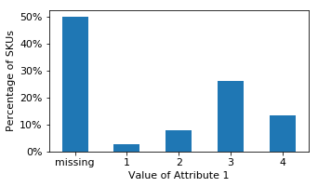

Figure 1: Distribution of Attribute 1 across All SKUs

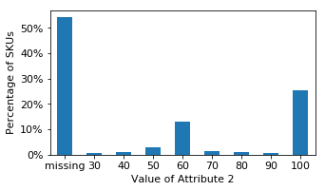

Figure 2: Distribution of Attribute 2 across All SKUs

For each SKU, the *skus* table provides two extra elements: *activate_date* and *deactivate_date.* The former specifies the date at which an SKU is first introduced on the JD.com platform and the latter specifies the date at which the SKU is terminated and removed from JD.com.[6] Notice that the data set only lists a valid *activate_date* and *deactivate_date* when one of these dates occurred within the month of March in 2018. If one of these fields is empty, this means that the SKU was activated before March 2018 and/or deactivated after March 2018. Our records indicate that 1,141 SKUs were deactivated and 3,058 SKUs were activated during March, and their monthly sales account for 2% and 5% of the total monthly sales, respectively.

1. **Table: users**

The *users* table (Table 2) describes the characteristics of each of the 457,298 users who purchased at least one of the SKUs in the given category during March of 2018. We now define each field along with a brief description. Each entry in the *users* table corresponds to a unique customer (*user_ID*). The field *first_order_month* specifies the month when the user made his or her “first purchase” on JD.com.

|  |  |  |  |
| --- | --- | --- | --- |
| Field | Data type | Description | Sample value |
| user_ID | string | User unique identification code | 000000f736 |
| user_level | int | User level | 10 |
| first_order_month | string | First month in which the customer placed an order on JD.com (format: yyyy-mm) | 2017-07 |
| plus | int | If user is with a PLUS membership | 0 |
| gender | string | User gender (estimated) | F |
| age | string | User age range (estimated) | 26–35 |
| marital_status | string | User marital status (estimated) | M |
| education | int | User education level (estimated) | 3 |
| purchase_power | int | User purchase power (estimated) | 2 |
| city_level | int | City level of user address | 1 |

**Table 2: Description of the *users* table**

For each repeat customer, the corresponding user is classified according to his or her past purchases so that the customer’s *user_level* takes on a value of 0, 1, 2, 3, or 4, where a higher *user_level* is associated with a higher total purchase value in the past. For users who are enterprise users (e.g., small shops in rural areas or small businesses), the corresponding *user_level* takes on a value of 10. However, for first-time purchasers, their *user_level* takes on the value −1.[7] Figure 3 depicts the distribution of user levels for all 457,298 customers.

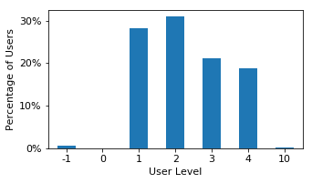

Figure 3: Distribution of Users: User Level.

If the field value of *plus* is 1, this denotes that the corresponding user is an existing PLUS member before March of 2018.[8] In addition to customer past purchase value and PLUS membership, the *users* table contains certain (*estimated*) user demographic information because JD.com’s customers are not required to provide any demographic information when making a purchase. However, JD.com has a sophisticated data-driven artificial intelligence system to estimate user demographics.

The estimated user demographics for each user are (a) *gender* (F: female, M: male, U: unknown); (b) *age* (<=15: less than or equal to 15 years old, 16-25: 16 to 25 years old, 26-35: 26 to 35 years old, 36-45: 36 to 45 years old, 46-55: 46 to 55 years old, >=56: greater than or equal to 56 years old, U: unknown); (c) *marriage* – user’s marital status (M: Married, S: Single, U: Unknown); (d) *education* – user’s education level (1: less than high school, 2: high school diploma or equivalent, 3: Bachelor’s degree, 4: post-graduate degree, −1: unknown); and (e) *purchase_power* – user’s estimated purchase power (ranging from 1 to 5 with 1 being the highest purchase power; −1 if there is no estimation).

In addition to those estimated demographics of each user, JD.com has provided actual information about the most commonly used shipping address for each user. This information is captured in the field *city_level*, which takes on values ranging between 1 and 5. Here, level 1 corresponds to highly industrialized cities such as Beijing and Shanghai; level 2 cities correspond to provincial capitals; level 3 to 5 cities are smaller cities; if there are no data then the value is −1. Notice that *city_level* is based on actual information.

Figure 4 depicts the distribution of user gender across all 457,298 customers in the database, and Figure 5 summarizes the distribution of estimated user age. As shown in Figure 6, for this specific product category, more than 60% of all customers are estimated to be female and the estimated ages of these customers are in their 30s to 40s. From Figure 6, we observe a relatively even distribution between married and single customers. Figures 7 and 8 provide the customer’s estimated education level and purchase power. Figure 9 summarizes the distribution of shipping address according to different city levels. It can be seen that most of the customers are from tier 1 and tier 2 cities.

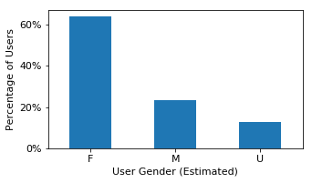

Figure 4: Distribution of Users: Gender

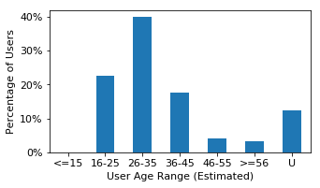

Figure 5: Distribution of Users: Age

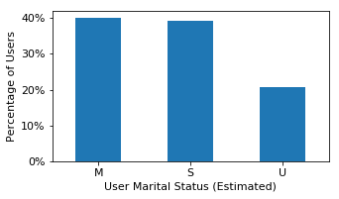

Figure 6: Distribution of Users: Marital Status

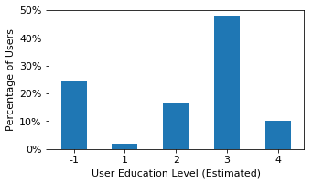

Figure 7: Distribution of Users: Education Levels

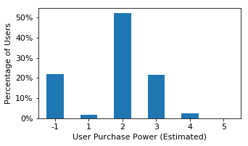

Figure 8: Distribution of Users: Purchase Power Levels

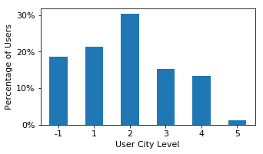

Figure 9: Distribution of Users: City Levels

1. **Table: clicks**

The *clicks* table (Table 3) establishes the linkage between users and SKUs through their browsing history. Each entry in the *clicks* table represents a user’s “click event” on a specific SKU page.[9] The date set contains over 20 million click records that are associated with the clicks of 2.5 million customers. Note that this table contains clicks contributed not only by the users identified in the *users* table (Table 2) who purchased at least one SKU but also by “other users” who did not end up completing a purchase order.

|  |  |  |  |
| --- | --- | --- | --- |
| Field | **Data type** | **Description** | **Sample value** |
| sku_ID | string | SKU unique identification code | b4822497a5 |
| user_ID | string | User unique identification code | 94ff800585 |
| request_time | string | The time at which the customer clicks the SKU item page (format: yyyy-mm-dd HH:MM:SS) | 2018-03-01 23:57:53 |
| channel | string | The click channel | wechat |

**Table 3: Description of the *clicks* table**

The records include the following: (a) the user who initiated a “*click event”* (*user_ID*), (b) the SKU associated with the click event (*sku_ID*), (c) the time at which the click event occurred (*request*_*time*), and (d) the channel in which the click event occurred (*channel*).[10] We classify the channel taken as five string values: *pc*, *mobile*, *app*, *wechat*, and *others*. Channels *pc* and *mobile* are associated with clicks through web browsers on personal computers and mobile devices, respectively. Channel *app* corresponds to JD.com’s mobile app. Channel *wechat* corresponds to the mini-program that runs on the social media app WeChat. Finally, channel *others* aggregates the clicks from all other channels.

The distribution of all click events across all channels is summarized in Figure 10. Because of the popularity of smartphones in China and the popularity of mobile payment options (e.g., WeChat payment), the majority of click events come from the *app* and *wechat* channels.

The field *request time* provides extra granularity. It can be used to infer the customer browsing sequence and habits. In Figure 11, we plot the number of clicks during the day on March 1, 2018, within the *app* channel. We can clearly identify two peaks in the daily browsing activities: one from 8am to 4pm in the day and the other in the late evening.

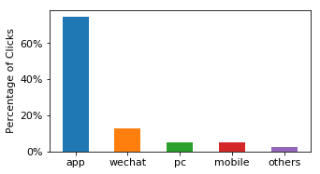

Figure 10: Distribution of All Click Events Across Different Channels

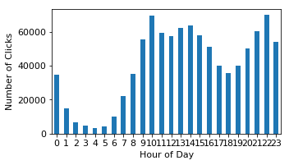

Figure 11: Number of Click Events Occurring on March 1, 2018, through JD.com’s App Channel

1. **Table: orders**

The *orders* table (Table 4) contains 486,928 unique customer orders associated with our focused product category that were placed during the month of March in 2018. Each customer order (*order_ID*) in the *orders* table is based on a specific SKU (*sku_ID*) associated with a unique customer (*user_id*). (If a customer ordered multiple SKUs, then the same *order_ID* will appear in multiple rows of SKUs.)

|  |  |  |  |
| --- | --- | --- | --- |
| Field | Data type | Description | Sample value |
| order_ID | string | Order unique identification code | 3b76bfcd3b |
| user_ID | string | User unique identification code | 3cde601074 |
| sku_ID | string | SKU unique identification code | 443fd601f0 |
| order_date | string | Order date (format: yyyy-mm-dd) | 2018-03-01 |
| order_time | string | Specific time at which the order gets placed (format: yyyy-mm-dd HH:MM:SS) | 2018-03-01 11:10:40.0 |
| quantity | int | Number of units ordered | 1 |
| type | int | 1P or 3P orders | 1 |
| promise | int | Expected delivery time (in days) | 2 |
| original_unit_price | float | Original list price | 99.9 |
| final_unit_price | float | Final purchase price | 53.9 |
| direct_discount_per_unit | float | Discount due to SKU direct discount | 5.0 |
| quantity_discount_per_unit | float | Discount due to purchase quantity | 41.0 |
| bundle_discount_per_unit | float | Discount due to “bundle promotion” | 0.0 |
| coupon_discount_per_unit | float | Discount due to customer coupon | 0.0 |
| gift_item | int | If the SKU is with gift promotion | 0 |
| dc_ori | int | Distribution center ID where the order is shipped from | 29 |
| dc_des | int | Destination address where the order is shipped to (represented by the closest distribution center ID) | 29 |

**Table 4: Description of the *orders* table**

Other information associated with a customer order as shown in Table 4 include (a) order quantity for each SKU associated with the order (*quantity*), (b) the date and time when the ordering event took place (*order_date* and *order_time*), (c) the type of SKU being ordered (type = 1 if it is a 1P SKU and type = 2 if it is a 3P SKU), and (d) the promised delivery time of the order (*promise*).[11] Observe from Figure 12 that most orders have promised delivery dates within 2 days. Figure 13 shows the total number of sales by date and by order type.

The *orders* table also offers information about product pricing and promotional activities for each SKU. For each entry, we denote the original list price of the SKU in the field *original_unit_price* and the actual paid price by the customer for the SKU as *final_unit_price*. The original list price of an SKU at any given time instant is the same for all customers, but the final price can vary among customers owing to various discounts or promotions.

The “gap” between the original price and the final price represents the coupons and discounts associated with different promotional activities for each SKU. There are four common types of promotional discounts on the JD.com platform: (1) SKU direct discount, (2) group promotion, (3) bundle promotion, and (4) gift items.[12] These four types of discounts can be described as follows:

1. The seller of an SKU may offer a price cut in terms of a *direct discount*. This discount reflects the reduction in the list price as stated on the product detail page.
2. The seller of an SKU may offer a *quantity discount* to entice the customer to buy more. This quantity discount promotion can take different forms including “get an RMB 100 discount if buying over RMB 199” or “buy 3 and get 1 free.” We note that the quantity discount promotion is usually on the order level and we apply a simple allocation rule to calculate the contribution provided by each SKU in the order.
3. The seller may offer a *bundle_discount* if a customer buys a “pre-specified bundle” of SKUs within an order.
4. The seller may offer an SKU as a “free gift” (*gift_item* value = 1) if the customer purchases a “pre-specified set” of SKUs (e.g., get a free eraser if you buy *x* pencils and *y* pads of paper). The *final_unit_price* for each gift item is always equal to 0.

Coupons can also be applied to the order after all other promotions are applied. In contrast to the four aforementioned promotion activities where discounts will be applied automatically once certain criteria are met, customers need to “clip” (or claim) a coupon before making a purchase.[13] The field *coupon_discount* records the coupon promotional value associated with an order. Similar to *quantity discount* as explained earlier, the discount value of the coupon is allocated between items in the same order using an allocation rule when necessary.

We note that, for each entry in the *orders* table, the gap between *original_unit_price* and *final_unit_price* should always equal the sum of *direct_discount*, group_discount, *bundle_discount*, and *coupon_discount*.

Finally, for each order, we show from which district the order was shipped (*dc_ori*) and to which district the order was shipped (*dc_des*). The district here is defined by the warehouse ID that covers the demand of that district. In other words, one can think of *dc_ori* as the warehouse where the package is shipped from and *dc_des* as the warehouse that is nearest to the customer’s designated shipping address. If *dc_ori* and *dc_des* are the same, this means that the package is shipped from the warehouse closest to the customer. Otherwise, it indicates that the package is fulfilled by some other warehouse in a different district. We note that in theory any warehouse in the nationwide network can fulfill any customer in the country. However, in practice, there is a complicated order fulfillment logic that determines what inventory should be used to fulfill each customer order to optimize fulfillment resources while satisfying delivery promise.

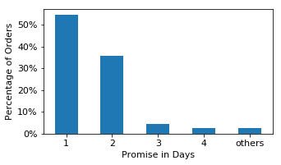

Figure 12: Distribution of Promise Delivery Time (1P Orders)

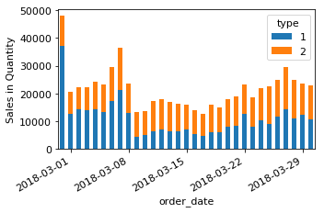

Figure 13: Sales in Quantity by Date and Order Type

1. **Table: delivery**

The *delivery* table (Table 5) establishes the linkage between each order (*order_ID*) and (possibly) multiple shipping packages (i.e., multiple *package_IDs*) in the event that an order is split into multiple delivery packages for logistical reasons (e.g., an order that involves in-stock and on-order items).

|  |  |  |  |
| --- | --- | --- | --- |
| Field | Data type | Description | Sample value |
| package_ID | string | Package unique identification code (same as order_ID if the package contains all SKUs in the order) | 209a005c40 |
| order_ID | string | Order unique identification code | 209a005c40 |
| type | int | 1P or 3P orders | 1 |
| ship_out_time | string | The timestamp when the package is shipped out from the warehouse (format: yyyy-mm-dd HH:MM:SS) | 2018-03-01 08:37:33 |
| arr_station_time | string | The timestamp when the package arrives at the station (format: yyyy-mm-dd HH:MM:SS) | 2018-03-01 15:37:31 |
| arr_time | string | The timestamp when the package is delivered to the customer home (format: yyyy-mm-dd HH:MM:SS) | 2018-03-01 18:49:03 |

**Table 5: Description of the *delivery* table**

The *delivery* table contains 293,229 packages delivered by JD Logistics in the given time period, among which 244,333 orders involve 1P SKUs (*type* = 1) and 48,896 orders involve 3P SKUs (*type* = 0). We further provide three key timestamps (up to hourly granularity) for each package delivery, namely, the time at which the package was shipped from the warehouse (*ship_out_time*), the time at which the package arrived at the delivery station (*arr_station_time*), and the time at which the package was successfully delivered to the customer (*arr_time*).

1. **Table: inventory**

The *inventory* table (Table 6) provides information about the availability of each SKU (*sku_id*) at each warehouse (*dc_ID*). We only disclose the availability of the inventory *at the end* of the day (*date*) instead of the amount of inventory. In addition, when an SKU is not available at a specific warehouse on a specific day, there will be no record of that SKU at that warehouse on that day.

|  |  |  |  |
| --- | --- | --- | --- |
| Field | Data type | Description | Sample value |
| dc_ID | int | Distribution center ID | 9 |
| sku_ID | string | SKU unique identification code | fcc883f713 |
| date | string | Date (format: yyyy-mm-dd) | 2018-03-01 |

**Table 6: Description of the *inventory* table**

1. **Table: network**

The *network* table (Table 7) provides information about the assignment of different warehouses located in different districts (*dc_ID*) to different geographical regions (*region_ID*). For each district, a designated warehouse (*dc_ID*) is responsible for fulfilling orders in the district. In addition, for different districts that are assigned to a geographical region, one of the (larger) warehouses will be designated as the “central warehouse” for that region. In JD.com’s context, a central warehouse provides the “back-up fulfillment” option when other (typically smaller) warehouses in the region run out of inventory for their corresponding districts. Figure 14 shows the number of districts within each geographical region. We denote each central warehouse for each region by setting *dc_ID* = *region_ID*.

|  |  |  |  |
| --- | --- | --- | --- |
| Field | Data type | Description | Sample value |
| region_ID | int | Region ID | 2 |
| dc_ID | int | District ID (same as warehouse ID) | 6 |

**Table 7: Description of the *network* table**

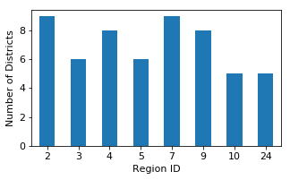

Figure 14: Number of Districts within the Regions

# 3. Conclusion

The data sets provided by JD.com are presented in seven tables as described above. These data sets are based on the activities associated with 2.5 million users (among them 457,298 with purchases) and 31,868 SKUs over the month of March in 2018. We also present potential research questions suggested by JD.com. Researchers are welcome to develop econometric models or data-driven models using this database to address some of the suggested questions or examine their own research questions.

The data sets include product information (attributes, pricing, etc.), customer information (demographics, total value of past purchases, PLUS membership, etc.). In addition, the data sets capture a “full customer experience cycle” that begins at the moment when a customer chooses the products on the platform and ends at the moment when the customer receives the products at his or her designated location.

# 4. Downloading the Data and Python Code

MSOM members can access the data sets thorough the MSOM website XXXX. For easy access, we provide a Python notebook[14] with runnable sample code to facilitate reviewing and understanding of the data sets as well as to explain the relationships among the seven tables described in this paper. The code is provided in the online appendix, and a runnable version is available within the data set package.

1. JD.com’s PLUS membership is a subscription-based program that provides its members certain benefits that range from free shipping to member-specific price discounts. For details about JD.com’s PLUS membership, see <https://plus.jd.com/index.html> (Chinese Content).
2. Note that the data provided by JD.com represent only a small sample of users and SKUs. Therefore, the database does not necessarily fully capture the business performance or business trends of JD.com.
3. All SKUs are displayed on JD.com’s product page with the seller name and/or tags so that customers are fully aware of whether the corresponding SKU is a 1P SKU or a 3P SKU.
4. The fulfillment process is usually described on the product page so that customers will know that the shipping process is managed by the merchant itself.
5. JD.com displays product ratings for each SKU. However, in the Chinese marketplace, most product ratings reported by customers are usually the highest rating. Because most ratings are rated 5, the information associated with product ratings has been shown to be uninformative. Consequently, product ratings are omitted in the database.
6. Note that, even though an SKU is deactivated, it may still be able to be bought as a part of a bundled product or as the gift portion of a promotion.
7. Regardless of different users’ *user_level* values, they observe the same information and receive the same service from JD.com.
8. JD PLUS membership costs up to US$45 per year and members enjoy a variety of perquisites including exclusive discounts, higher purchasing reward rate, free delivery, and return with no pre-conditions. About 18% of those 458,269 customers in the data set are JD PLUS members.
9. It is worth noting that this table only contains click information on the SKU detail page. There are many other page types with which a customer can interact on JD.com, such as the website main page, category main page, various landing pages, search, recommendation page, shopping cart page, etc. Although those pages also contain information about SKUs and promotions, the customers still need to go to the SKU detail page to review the detailed description of the products and place the order.
10. Note that these data capture the click event of an SKU initiated by a user, but each click event may not lead to the purchase of this SKU. In other words, a user may choose not to purchase this SKU even after the click event.
11. When *promise* = 1, this refers to the standard same- and next-day delivery promise: Orders placed before 11am will be delivered on the same day, and orders placed before 11pm will be delivered before 3pm on the following day. When *promise* is *x* (*x* > 1), this indicates that the delivery will arrive at day *t* + *x*, where *t* is the day the order is placed. We note that *promise* information is not available for a small fraction of 1P orders and for most of the 3P orders.
12. In addition to the discounts, coupons are also commonly used to reduce the final paid price by customers.
13. Coupons normally consist of a discount value, an eligibility criterion, and an expiration date. The discount value is the monetary amount that can be deducted from the order; the eligibility criterion specifies which SKU or SKU set is eligible for coupon use and whether there is a total purchase amount criterion. The expiration date shows when the coupon can be applied. There are many ways in which customers can receive a coupon. They can clip coupons from the product detail pages, promotional landing pages, or “coupon mall” (a specific section on the JD.com platform for coupon distribution). Customers can also receive personalized coupons based on their past activities.
14. https://jupyter.org/